END OF FIRST TERM EXAMINATION
CLASS: JHS 1 SUBJECT: INTEGRATED SCIENCE
NAME…………………………………………………..……………………... DURATION: 2 HRS

SECTION A: OBJECTIVES

- All the following involves scientific experimentation except?
- Observation
- Title of experiment
- Conclusion
- Creation of result
- Which of the following statements best describe the misuse of the knowledge of Science?
- Construction of canals and dams for irrigation
- Making of atomic bombs
- Invention of farm machinery like tractors for farming
- Invention of communication satellite
- Which of the following area of study is applied science?
- Chemistry
- Medicine
- Biology
- Physics
- Science can be defined as a method of obtaining knowledge through
- guesses
- libation and ablution
- observation and experimentation
- prayer
- The newton is the unit for measuring
- volume
- mass
- weight
- area
- Which of the following is equal to 1kg?
- 1000mg
- 1000g
- 100g
- 100mg
- The degree of hotness or coldness of a body is referred to as its
- heat capacity
- temperature
- internal energy
- melting point
- The word meniscus refers to the
- volume of a liquid
- mass of a liquid
- density of a liquid
- curved surface of a liquid
- Which of the following is a derived unit?
- Metre
- Kilogram
- Newton
- Second
- If the normal human body temperature is 36$℃$. Which of the following is an equivalent value on Kelvin scale?
- 173.0K
- 236.4K
- 309.0K
- 312.0K
- How many states of matter are there
- 3
- 4
- 5
- 6
- Which of the following substances can exist in all the three states of matter?
- Petrol
- Palm oil
- Milk
- Water
- The muscle is an example of
- a system
- an organ
- a tissue
- an organelle
- When a piece of candle is heated, it changes from
- liquid to gas
- liquid to flame
- solid to liquid
- solid to gas
- The basic unit of matter is the
- atom
- compound
- element
- ion
- The following are components of a fertile soil except?
- Air
- Water
- Humus
- Gravels
- Which of the following soil types allows high rate of drainage?
- Clayey soil
- Humus
- Loamy soil
- Sandy soil
- What is the name of the gas that is found in soil water?
- Ammonia
- Methane
- Oxygen
- Nitrogen
- The process whereby soil is formed by the breakdown of rocks is called
- erosion
- weathering
- fertilization
- leaching
- Which of the following statements about clayey soil is not true?
- It is difficult to plough when dry
- It shrinks when wet and swells when dry
- It has high amount of plant nutrients
- It has the smallest soil particle
- Care must be taken to avoid bringing a naked flame near substances that
- combustible
- corrosive
- magnetic
- toxic
- Which of these methods would be use to put out fire if someone’s clothing catches fire in the kitchen?
- Sand bucket
- Fire blanket
- Add cold soil
- Carbon dioxide gas
- Which of the following disabilities may be common among workers in noisy environment?
- Blindness
- Deafness
- Dumbness
- Lameness
- A combustible substance is one that
- easily catches fire
- dissolves common salt
- freezes at 0$℃$
- boils at 100$℃$
- The first step to take when there is an electrical fault is to
- call the fire service
- switch off the electrical mains
- call an electrical engineer
- vacate the premises
- ……… is the study of animals
- Botany
- Zoology
- Virology
- Bacteriology
- The use of computer to process information is known as
- food technology
- biotechnology
- zoology
- pathology
- The following are harmful effect of science and technology except……
  - creation of massive unemployment
  - importation of negative foreign culture into our society
  - destruction of wildlife
  - exploration of oil deposited in the sea
- The mass of Sir John’s phone is 0.1kg. What will be the weight of the phone?

- The measure of period between two events is
  - length
  - mass
  - time
  - density
- The amount of space occupied by matter is
  - area
  - volume
  - length
  - weight
- The process by which living things increase in number is referred to as
  - multiplication
  - growth
  - reproduction
  - development
- Water changes into vapor at
  - 0$℃$
  - 100$℃$
  - 37$℃$
  - 10$℃$
- The process by which steam is changed into water is called……
  - evaporation
  - condensation
  - melting
  - sublimation
- Virus can only produce when they in a
  - culture solution
  - living organism
  - dead matter
  - sugary medium
- The physical property that refers to how rough or smooth a soil is, is known as
  - capillarity
  - air content
  - water holding ability
  - texture
- Mimosa closes its leaves when the leaves are touched. This means.
  - Mimosa dislikes touches
  - Mimosa is sensitive to touch
  - The leaves of mimosa are very soft
  - The leaves of mimosa are very large.
- Which of the following is the organic part of the soil?
  - Humus
  - Air
  - Soil particles
  - Mineral salt
- Which of the following is not a soil nutrient?
  - Hydrogen
  - Nitrogen
  - Potassium
  - calcium
- The S.I unit for distance is…….
  - Km
  - M
  - Mile
  - Cm

SECTION B: ESSAY
Answer Q1 and any other two
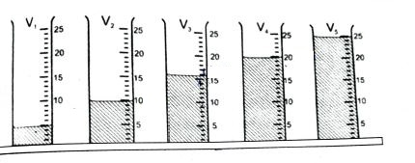
- a. i. Read and record in cm³ the volume of liquid in the following cylinder (show working).

- ii. Read and record the following time in second for the stop watch below
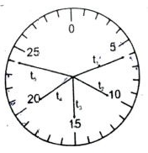

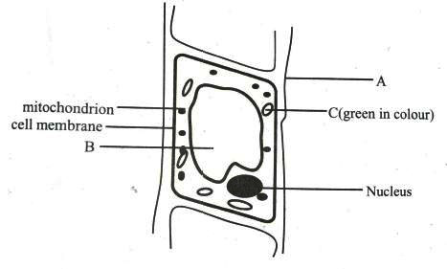

- identify the cell above
- name the parts labelled A,B and C
- state the function each for the parts labelled A, and B
- what pigment is found in structure C
- what is the function of this pigment
- what is the function of the mitochondrion

- a. i. What is an organelle?
ii. List four organelle that are found in plant cell.
- i. Define the following and state one function or importance of each.
- soil air
- soil water
- organic matter
- i. Convert the following into metres
- 500 cm
- 650 km
- 10000 cm
ii. A stone of mass 80.0g was gently dropped into measuring cylinder containing a water. If the level of the water rose from 78cm³ marks to 80.0cm marks. Calculate the density of the stone.

- a. i. Briefly explain the following
- excretion
- respiration
- reproduction
ii. State three (3) similarities between plant and animal
b. i. What is weathering of rock?
ii. Outline three (3) agents that causes weathering of rock.
c. i. What is density?
ii. Explain why a steel ship would float on water

- a. i. What is technology?
ii. State three (3) differences between science and technology
b. i. state the SI unit for the following substance
- amount of substance
- mass
- temperature
- velocity
- area
ii. State three (3) differences between mass and weight
- Find the density of cylindrical substance with radius of base r = 0.1m and height, h = 0.5m, if the mass of the cylinder is 44kg (take $π$= 22/7) Clue: volume of cylinder = $π$r²h

- a. i. What is a cell?
ii. state five characteristics of living things.
iii. state three differences between plant cells and animal cells.
b. i. State three importance of the soil to plants and animal.
ii. Mention three components of soil.
c. i. Explain why a piece of object like copper would sink in water.
ii. Explain how you would determine the volume of irregular object (stone).

